Classical Guitarist
Harold Micay
In Recital

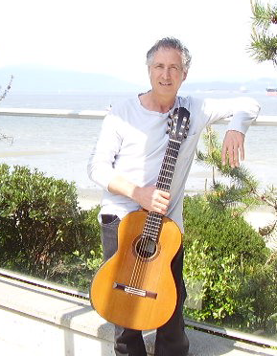
St Mark’s Anglican Church
1805 Larch St.
@ 2nd Ave.

$20 adults
$15 seniors, students, VCGS members

At the door
Sunday
November 8
3:30 pm

Sor, Tarrega, Krause, Ponce, Albeniz, Lauro

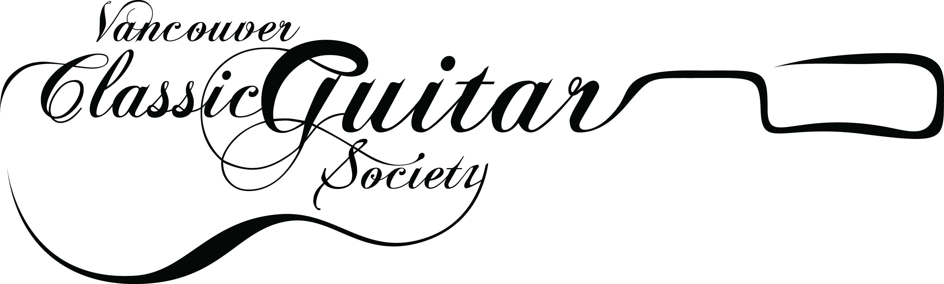

Presented by The Vancouver Classic Guitar Society, 18-5729 W. Boulevard. Vancouver, BC V6M 3W8 www.vancouverguitar.org, Vancouvercgs@gmail.com, (604) 261-9380

